

**Proposed Plan EGames Community Website for Humber College**

**Introduction:**

* **Why This Document:** The vision and strategy plan of the development of a cutting-edge game's website for EGames are presented in this detailed proposal. To our commitment to not simply meet, but exceed the digital expectations of Egames in an ever-changing gaming landscape this document serves as a testimony.
* **Project Context:** A compelling online presence is no longer an option in today's digitalised world; it must be a precondition for success. In response to the urgent need for Egames website, we have developed this proposal with a view of establishing an effective online presence. It is recognised that the absence of an online platform prevents Egamers from being able to connect with its increasing gaming community.
* **General objectives:** To accelerate Egames to the forefront of technological development, creating a robust and interactive internet environment in which gaming experiences are mirrored by their excitement and dynamism. It aims to go deeper than the creation of a website; it envisages an Internet Community Hub where E Games' products are displayed but that is also fostering community interaction, promoting brand loyalties and strengthening its standing within the video game industry.
* **Success Criteria:** Intangible results aligned with Egames' broader objectives will serve as a benchmark for the success of this project. Key success criteria are the increase in internet visibility, increasing community involvement and a positive impact on brand perception. In addition, we would like to create a website that is seamlessly integrated with the business of EGames and supports its growth.
* **Assumption Testing:** This document is designed to allow us to test our assumptions, in view of Egames' uniqueness and the dynamism of the gaming industry, as it will be a tool for proposing solutions that correspond with their needs and objectives. We are aiming at revising and adapting our strategies with a view to achieving the best possible outcome by means of collaboration and feedback.
* **Client-Centric Approach:** A great awareness of Egames' objectives and ambitions has been at the heart of this proposal. We are aware that a deep understanding of our clients' vision has given rise to successful projects. This document is proof of our expertise, but also a commitment to align it with the special requirements that Egames has for its website.

**What are Esports?**

Esports, short for online sports, is a form of video gaming in which professional players play individually or as teams against each other within organised tournaments and are often awarded substantial prizes. Esports offers a wide range of video games genres, and does not confine itself to the following:

* **Multiplayer Online Battle Arena (MOBA):** Games like League of Legends and Dota 2, where teams of players compete against each other in strategic battles.
* **First-Person Shooter (FPS):** Games like Counterstrike, Global Offensive and Overwatch, where players engage in combat from a first-person perspective.
* **Real-Time Strategy (RTS):** Games like StarCraft II, where players control armies and engage in strategic warfare.
* **Sport simulation:** games that simulate popular sports like football and basketball, for instance FIFA or NBA 2K.
* **Battle Royale:** games where players face off against one another to be the last player or team standing, such as Fortnite and PUBGPUBG.
* **Fight games:** Games, such as the Fighting Street and Super Mash Bros. that have two players fighting together or in team fights.

In the last ten years there has been an enormous development in esports, e.g. soccer and computer games that have significantly improved on a range of dimensions like popularity, infrastructure, investment and professionalisation. A few of the most significant trends and developments can be seen in the following table:

* **Increased Popularity:**
  + Esports has witnessed an unprecedented increase in popularity, thanks to the growing fan base around the world. Large sporting events and leagues are being watched by millions of viewers both on the Internet and in person.
* **Professionalization:**
  + ESports have become a more formal and professional game by means of structured leagues, teams and player contracts. Professional status of players was recognised, the organisations were set up with a similar working model to sports teams.
* **Diversification of Games:** 
  + New players, such as Fortnite, Overwatch or Valorant, have arrived in the scene with a large fan base while existing games like League of Legends, Dota 2 and Counterstrike: Global Offensive keep gaining popularity.
* **Investment and Sponsorship:**
  + There has been a great increase of investments in the field by traditional sports teams, celebrities and large enterprises. Thanks to the growth of revenues in this sector, sponsorship agreements with large brands are becoming more frequent.
* **The rights of the media and broadcasting:**
  + Esports broadcasting has developed as major networks and streaming services have secured the rights to show it. Exclusive arrangement with leagues and competitions, which enables the game to be enjoyed by a wider audience, are also part of this.

**What CMS do we propose?**

Our choice for the Content Management System (CMS) is WordPress. The user friendliness of its interface, the wide amount of plugins support and a large community of developers is what makes WordPress stand out. It is flexible enough to allow seamless content management and future scalability, in line with the dynamic nature of the EGames community.

|  |  |  |  |  |  |  |  |  |
| --- | --- | --- | --- | --- | --- | --- | --- | --- |
| CMS | Chatrooms | E-commerce | Student Logins | Event Calendar | Price (Most Expensive to Cheapest) | Advantages | Disadvantages | Overall Score (1-5) |
| WordPress | Yes | Yes | Yes | Yes | $$ | User-friendly, extensive plugin support, diverse themes. Can be resource-intensive, security vulnerabilities. | Can be resource-intensive, security vulnerabilities. | 3.5 |
| Joomla | Yes | Yes | Yes | Yes | $$ | Flexible, good for social networking features. Steeper learning curve than WordPress. | Steeper learning curve than WordPress. | 3.5 |
| Drupal | Yes | Yes | Yes | Yes | $$$ | Highly customizable, robust for complex websites. Steeper learning curve may require more development expertise. | Steeper learning curve may require more development expertise. | 4.25 |
| Magento | No | Yes | Yes | Yes | $$$$ | Excellent for e-commerce, scalability. Complex for non-eCommerce features, resource intensive. | Complex for non-eCommerce features, resource intensive. | 3.25 |
| Shopify | Yes | Yes | Yes | Yes | $$ | Simple e-commerce setup, good for beginners. Limited customization compared to other CMS. | Limited customization compared to other CMS. | 3.0 |
| Squarespace | No | Yes | Yes | Yes | $$ | User-friendly, great design options. Limited customization compared to other CMS. | Limited customization compared to other CMS. | 3.25 |

**Which CMS features are helpful from WordPress?**

* **Customized Templates:**
  + Justification: Customizable templates are essential for the creation of an esports website with a distinctive and visually attractive design. Esports is not only about games, but also a matter of communities and brands. A website that stands out and gives visibility to the team's colours, logos and themes, which are well known in the gaming community, can also be created with custom templates. A distinctive appearance that can make them feel part of a community may be possible for the teams, players and tournament organisers.
* **User Management:** 
  + Justification: User management is necessary to ensure that esports users on the Internet have an exceptional experience. This shall include user logins, account creation and the ability for users to monitor and control their activities. Users who register are allowed to create their profile, keep track of teams and players they're interested in, be informed about future events or matches. Moreover, it facilitates community participation in user management through the provision of forums, comments and discussions.
* **Social Media Support:** 
  + *Justification*: Given the substantial presence of social media in esports, it is necessary to integrate support for them into the ecosystem. This feature will allow users to communicate their achievements, favourite moments and engage with the community in an easy way. Social media integration allows your website to automatically retrieve and display content from a variety of platforms, for example live streaming Twitter posts during the match, Instagram articles or YouTube videos.
* **E-Commerce Features:** 
  + Justification: Esports teams and organisations often have uniforms, which makes it easy for them to sell their own branded products directly on the Internet through a combination of e commerce features. In return, for each purchase of Team Uniforms, Hats and Special Products, fans may contribute to their team's income. E.U.S. functionality is also enhanced by offering a one stop shop for fans supporting their favourite teams or players, such as allowing them to buy products at the same time overall user experience.
* **Chatrooms and Chatbots:** 
  + Justification: Chatrooms and chatbots foster real-time communication within the esports community. During live events, chat rooms may be used to allow fans to connect, share knowledge, and express their excitement. Chatbots can be used to give quick support, answer questions and guide users through a website. You can also configure them to deliver an automatic update, e.g. schedules of matches, results, and news, increasing the number of users that use this option or using it more actively satisfaction.

**What are the features you would propose?**

* **Live Streaming:**
  + **Purpose:** To allow spectators to watch games, tournaments and live streams in real time by facilitating the broadcast of esports events.
  + **Implementation:** An interactive user's interface for a seamless viewing, integration with leading streaming sites and live broadcasting section on the website.
* **Information about the team and the player:** 
  + **Purpose:** Showcase teams and players participating in various esports competitions, providing background information and statistics.
  + **Implementation:** dedicated websites for teams and players, including bios, achievements as well as links to social media profiles.
* **Social Media Integration:** 
  + **Purpose:** By seamlessly integrating the website with popular social media platforms, the aim is to increase the involvement and reach of the community.
  + **Implementation:** Users will be able to interact with content on platforms like Twitter, Facebook, Instagram and others through their social media buttons, live feeds or sharing options.
* **Game Information:** 
  + **Purpose:** To provide detailed information on the games that are included in esports competitions such as instructions, updates and patch notes.
  + **Implementation:** Game specific websites where players and fans can get the latest news, patch notes, guidelines or other relevant information to be able to stay informed.
* **User Account:** 
  + **Purpose:** To allow users to create user accounts with the purpose of creating personalised experiences, participating in forums and accessing exclusive content.
  + **Implementation:** User registration and login features, profile customization options for tracking favourite teams, players or tournaments.
* **The chat rooms, the groups:** 
  + **Purpose:** The aim is to foster a sense of community interaction through the provision of space for live discussions, team fandoms and regular conversations.
  + **Implementation:** Connecting users to each other's interests, facilitating communication and building communities with chat rooms, forums and group functions.
* **E-commerce:** 
  + **Purpose:** Provide an opportunity for esports related merchandise, tickets and other products to be sold.
  + **Implementation:** An online store with secure payment gateways, products pages and features such as discounts, promotions or limited-edition items.

**What actions would you suggest confirming those features?**

* **Customized Templates:**
  + **wireframes and wire mock-up's:** Please ask the Design team to render frames and mock-ups of your customized templates. In order to ensure conformity with the intended image and look, these Visual Representations shall be reviewed.
  + **Prototype demonstration:** If you want to interact with the customized templates, ask for a prototype demonstration. Ensure that the user-friendliness of the customization options is ensured and that the desired visual appeal is achieved.
  + **User testing:** In order to gather feedback on the customised templates, user testing will be carried out with a sample audience. Before final implementation, take the opportunity of applying this feedback to make any required adjustments.
* **User Management:**
  + **User flow diagrams:** In order to ensure that the journey from creation of accounts to personalised experiences is smooth, review user flow diagrams. Verify that you are easily able to access key user management features, e.g. login, password creation and account settings.
  + **Beta Test:** Develop a beta version of your Web site and invite some selected user groups to try the User Management features. Give feedback about the process of registering, account management and personalised features.
* **Social Media Support:**
  + **Integration testing:** verify the smooth functioning of social media integration. Test sharing functionalities, embedding social media feeds, and pulling in content from various platforms.
  + **Cross-Platform Compatibility:** Ensure that social media features work consistently across different devices and browsers.
  + **Monitor Analytics:** Implement analytics tools to monitor social media engagement directly from the website. The performance of shared content and user interactions will be monitored.
* **E-Commerce Features:**
  + **Transaction testing:** evaluates the end-to-end shop process which includes product selection, customer management and payment processing.
  + **Security checks:** Make sure all transactions on the internet are secure. For the protection of user's data, implement SSL certificates and other security measures. Inventory
  + **Management:** verify that orders are processed in a proper fashion and the availability of goods is correctly reflected on the website.
* **Chatrooms and Chatbots:**
  + **Realtime Testing:** During a real time, event, the chatrooms are tested to communicate in real time. Check to see if there is any lag time or delay in sending the message.
  + **Chatbot interaction:** Verify that the chatbot is providing correct information and responds to users' questions in an appropriate manner.
  + **User feedback:** collect messages from users regarding their experiences in chat rooms and chatbots. Let you know of any issues identified in the test phase.

**Wire Frames:**

### **Home Page:**

Welcome to the heart of the gaming universe, your ultimate destination for eGames excitement! Our home page is designed to become your digital gateway, which will give you a glimpse into an exciting world of electronic sports. Here's what you're going to find:

#### Featured Games:

Discover the latest and most popular eGames right at your fingertips. From pulse-pounding action to strategic gameplay, our featured games cover a spectrum of genres to cater to every gamer's taste.

#### Upcoming Tournaments:

With our live tournament updates, we're keeping up with the most recent eGames competition. Look at the schedule, follow your favourite teams and take advantage of fantastic battles among some of the best players in online gaming.

#### Community Highlights:

You will find a vibrant eGames community. Get a taste of the user generated content, ranging from jaw smacking gameplay clips to witty strategy guides. Have a good time with the other gamers, share your experiences and celebrate our shared passion for electronic sports.

#### Exclusive Features:

By creating an account, you will be able to unlock certain features. You can customize your gaming experience, track your achievements, and gain access to exclusive content. You'll be a part of the next generation of Digital Games fanatics when you join our expanding community.

#### Shop the Latest Gear:

In our online shop you will find some of the most popular accessories and merchandise to upgrade your gaming system. Our shop is curated to enhance your gaming lifestyle, from high performance gaming peripherals to fashionable clothing.

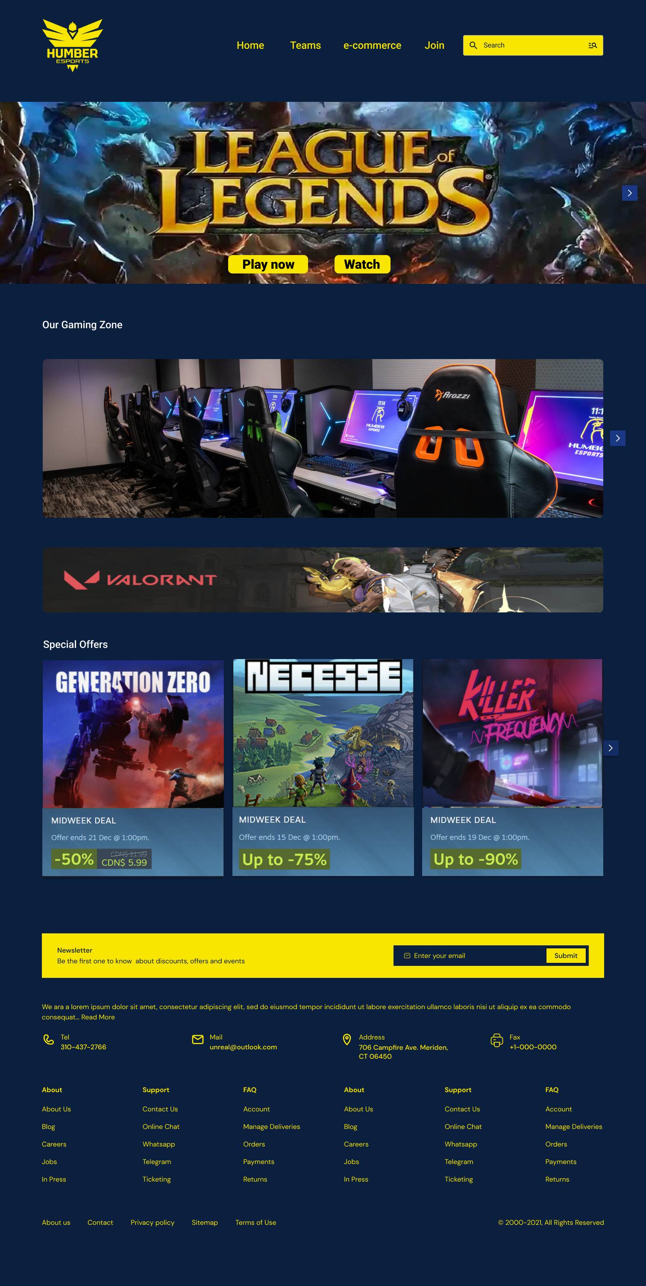

### **Signup Page:**

Would you like to be part of the gaming community? For the world of possibilities to be unlocked, you must sign up today. To access the special features, follow your progress and take part in exciting tournaments, make sure you have a personal account. In no time you will be able to participate in eGames experience, thanks to our Userfriendly sign-up process. You join us, you'll become part of an expanding community that is passionate about electronics sports!

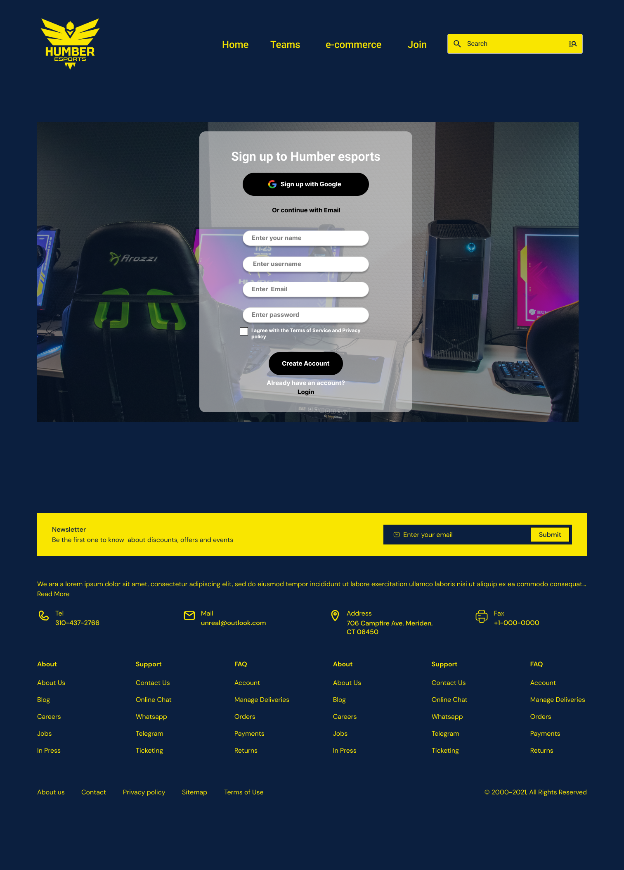

### **Teams Page:**

Create alliances and display your skill as a player on our team page. Connect with likeminded players, create or join teams and go on a collaborative gaming adventure. Our Team's page is your go to destination for building lasting gaming connections, whether you're building a team for competitive play or looking for friends to explore new games.

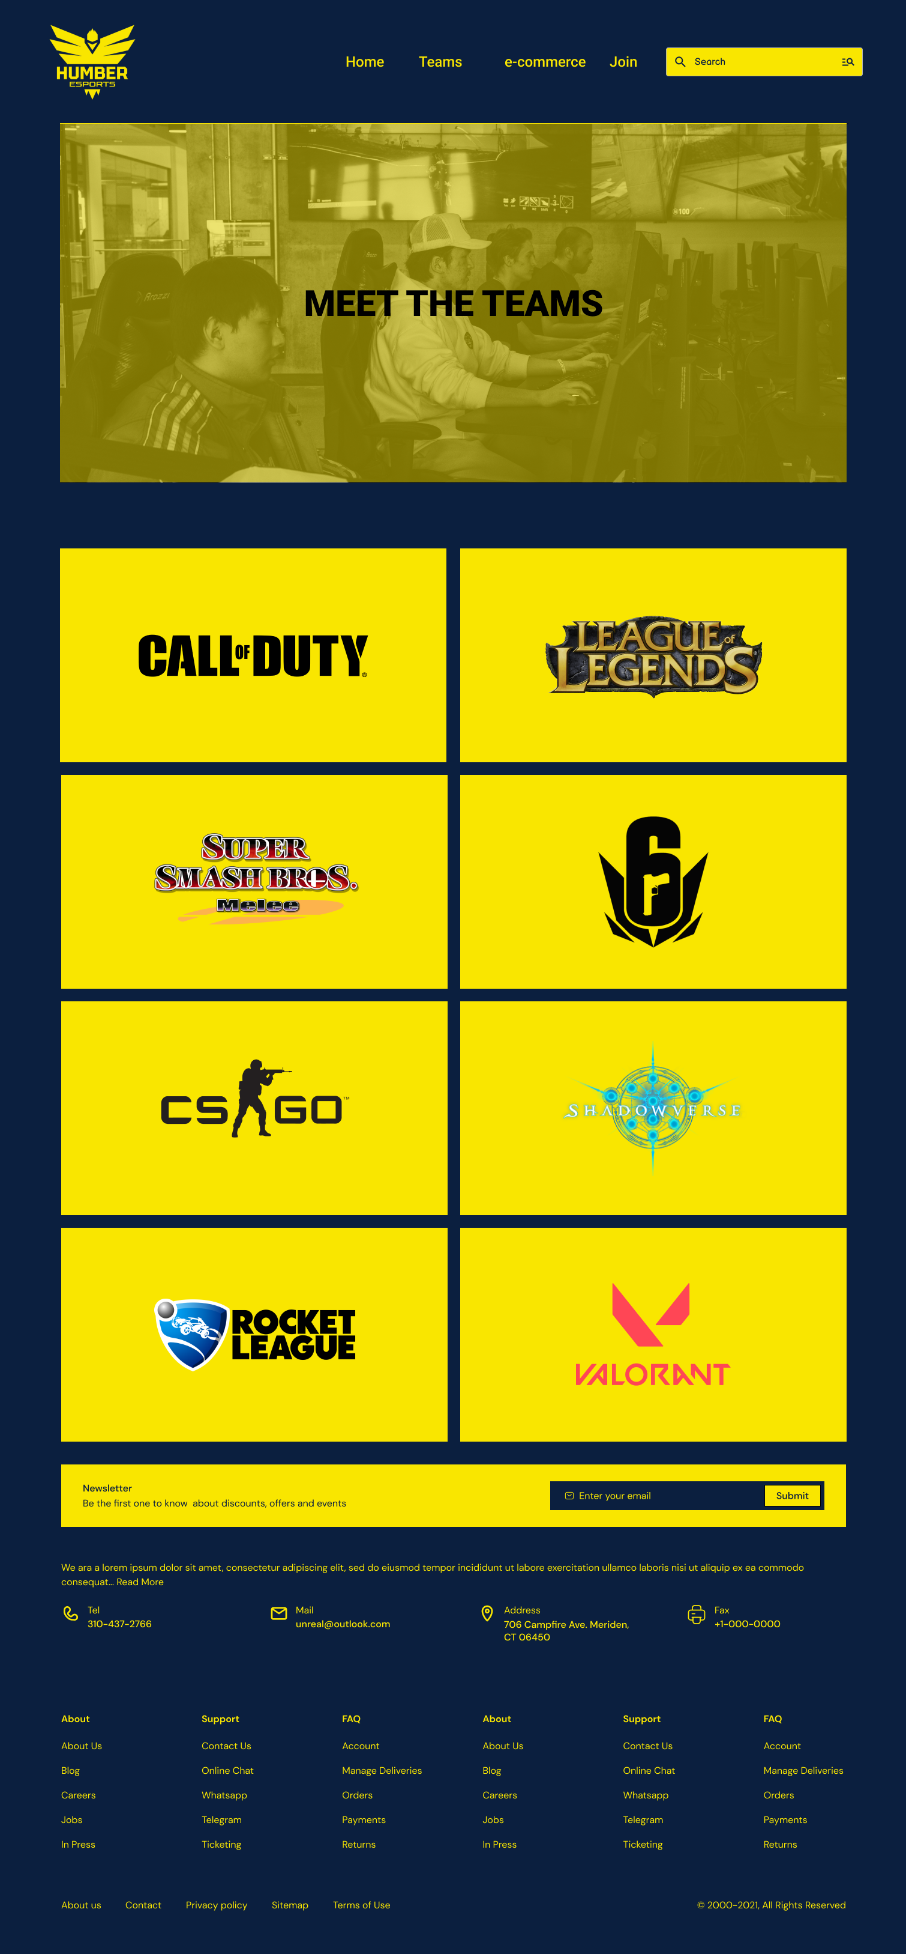

### **Rosters Page:**

To learn more about the skilled players that make our eGames platform a success, visit the Rosters page. This page profiles the talented individuals who shape the gaming industry, including experienced professionals as well as rising stars. Get to know your players' profiles, achievements and game statistics in order to learn more about the variety of talents within our eGames community.

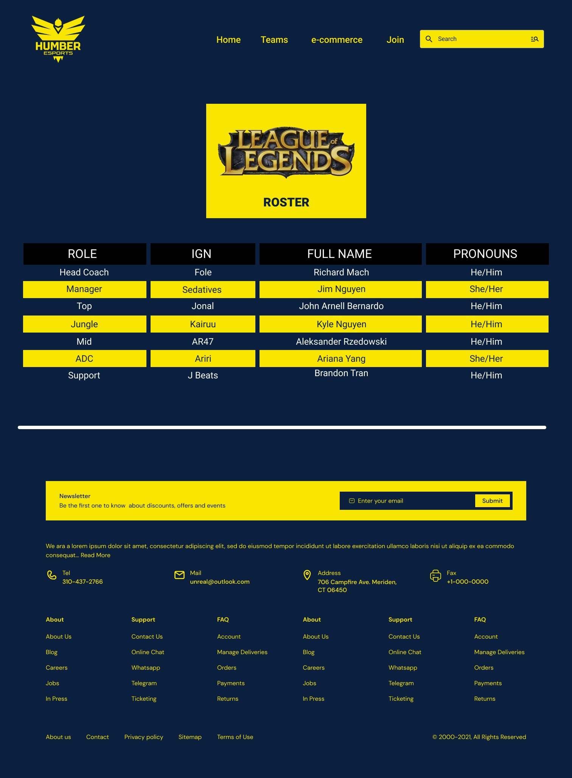

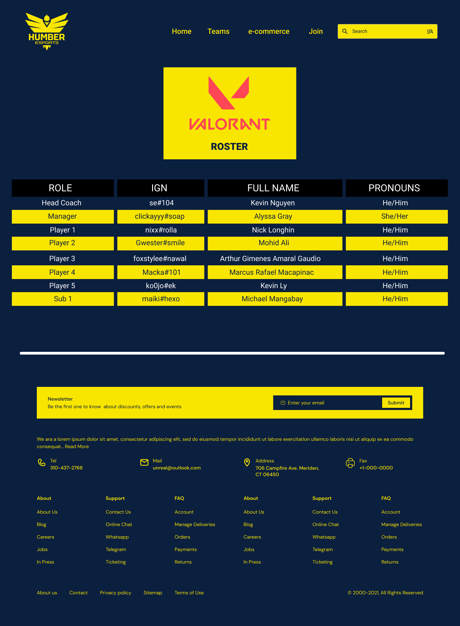

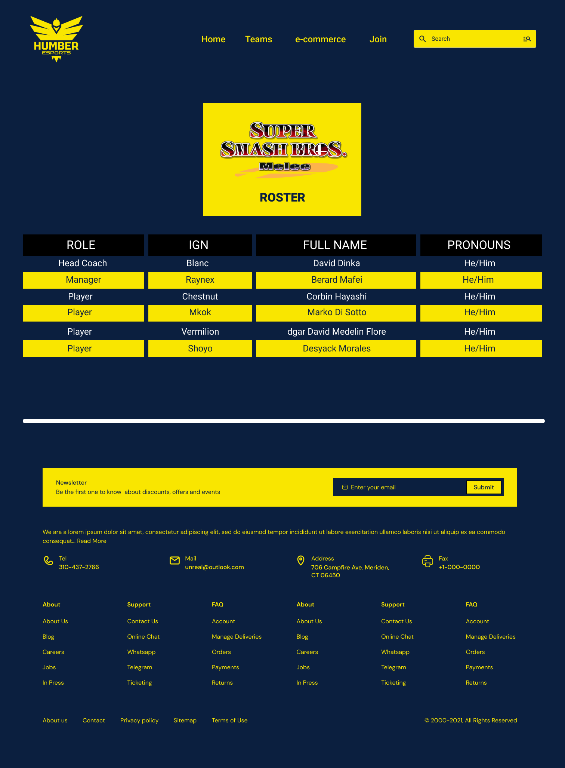

### **Chat Group:**

Try our Chat Groups feature, which will allow you to interact in real time with other gamers. Choose among the various channels dedicated to particular games, genres or topics of interest. Share strategies, discuss the most recent game releases or coordinate your team's strategy. The eGames community, fostering contacts and comradeship among players all over the world, meets in our chat group.

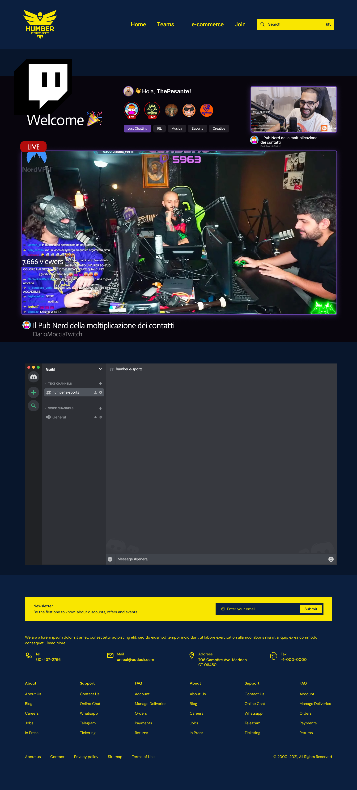

### **Ecommerce Section:**

Get ready for a victory with our Ecommerce section, where you'll be able to browse the selected selection of gaming accessories, products and eGames essentials. Whether you're dealing with advance technical peripherals or exclusively available brands of products, our Ecommerce platform will allow you to obtain access to the best tools and game accessories in order to enhance your gaming experience. You can improve the quality of your installation and game by using our eGames marketplace.

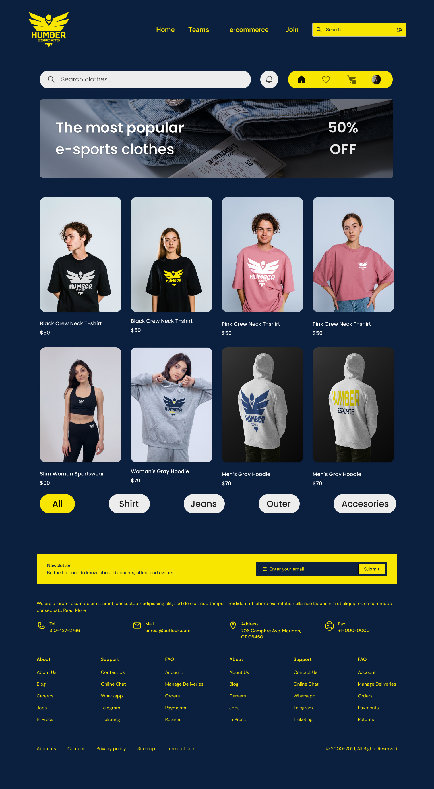

**Team Bios:**



My name is Vishalini. I'm a UX student at the University of Chicago. From India, I have earned my master's degree in computer science. I've been working or a couple of projects like wedding planning apps, food ordering apps. I've been working with my team and setting up an esports site based upon the small amount of knowledge I have.



Hello, I'm Diego Rivera, an Industrial Designer from Colombia. I'm passionate about web design, digital marketing, and dabble a bit in coding, specifically with React and React Native.

Currently, I'm delving into the Full Stack Developer world at Humber College in Canada. Beyond the tech stuff, I love arts, movies, and sports.



Hello, I’m Rachel Freedman, a UX design student here at Humber. I have a bachelor's degree in psychology from the university of Guelph and am new to the UX and technology field. I am passionate about learning new skills and meeting new people. My career goal is to blend my UX knowledge with fundraising and education to improve mental health supports. I am also interested in crocheting, knitting, and travelling.



I'm a Daksh Nagpal, by the way. I am currently enrolled in this course on interactive media management of creative technologies. I am a Graphic Designer who, by profession, is passionate about developing eye-catching graphics to express complex ideas in an easy and efficient way. In my spare time I explore new trends in the art of design and try out new tools and techniques for developing innovative designs.



My name is Suyash, and I'm an experienced IT professional with skills in a variety of technologies such as React.js, TypeScript, SharePoint SPFX, PowerShell, HTML, CSSC, Cnet &.NET. Skilled in crafting seamless, user-friendly optimized solution. My passion is to continuously learn and be updated on the latest trends in technology. Ready for cooperation on projects requiring innovation and efficiency in the information technology sector.

**Conclusion:**

To reflect the diverse interests and talents of the student gaming community at Humber College, the EGames Community website would aim to be an innovative, interactive platform for users with a user interface focused on interactivity. We are striving to create a Digital Space where we not only inform, but also engage and connect members through choice of WordPress as our content management system and the use of cutting-edge features.

The proposed EGames Community Web site is not simply a digital platform; it's the gateway for an innovative and connected gaming community at Humber College. We shall use the power of WordPress and introduce new features in order to build a Web site that breaks away from what is currently found on traditional gaming forums. This website isn't just a display of pages; this is an interactive platform where passions and tech meet, in which all members have the opportunity to contribute, connect with each other or celebrate diverse world of electronic gaming.

As a team, we're committed to building not just a website, but a virtual home for the EGames community, a space that evolves with its members, fostering collaboration, competition, and continuous growth. Let's make this experience in the E Games be even better!

In future steps we ask you to support and cooperate so that our vision becomes a reality. To ensure a successful development and launch of the Egames.com website, we are very grateful for your comments and feedback as well as working closely with you throughout this process.

The prospect of turning Egames into the internet's leading company is very exciting to us, and we want to join them in their continued success. Thank you for taking the time to think about our proposal, and we're looking forward to starting this journey together.